Set 16: Customer Demographics Analysis
a) Create a bar chart to visualize the distribution of customer ages. Label the axes and title the chart.
R code:
# Dataset
customer <- data.frame(
CustomerID = c(1, 2, 3),
Age = c(28, 35, 42),
Gender = c("Female", "Male", "Female"),
Income = c(50000, 60000, 75000)
)

# Bar Chart
barplot(customer$Age,
names.arg = customer$CustomerID,
col = "skyblue",
xlab = "Customer ID",
ylab = "Age",
main = "Distribution of Customer Ages")
output:
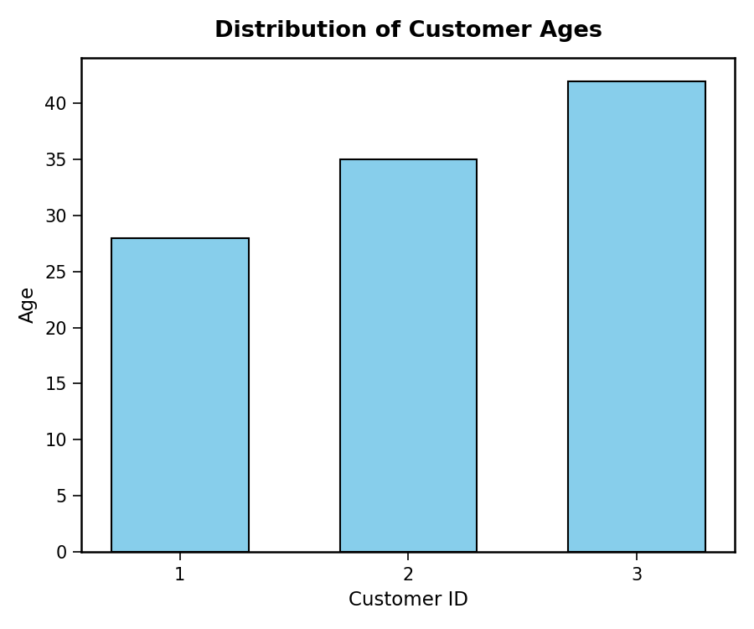
b) Generate a pie chart to represent the distribution of customers by gender.
R code:
# Count Gender
gender_count <- table(customer$Gender)

# Pie Chart
pie(gender_count,
labels = paste(names(gender_count), round(100*gender_count/sum(gender_count),1), "%"),
col = c("pink", "lightblue"),
main = "Customer Gender Distribution")
output:
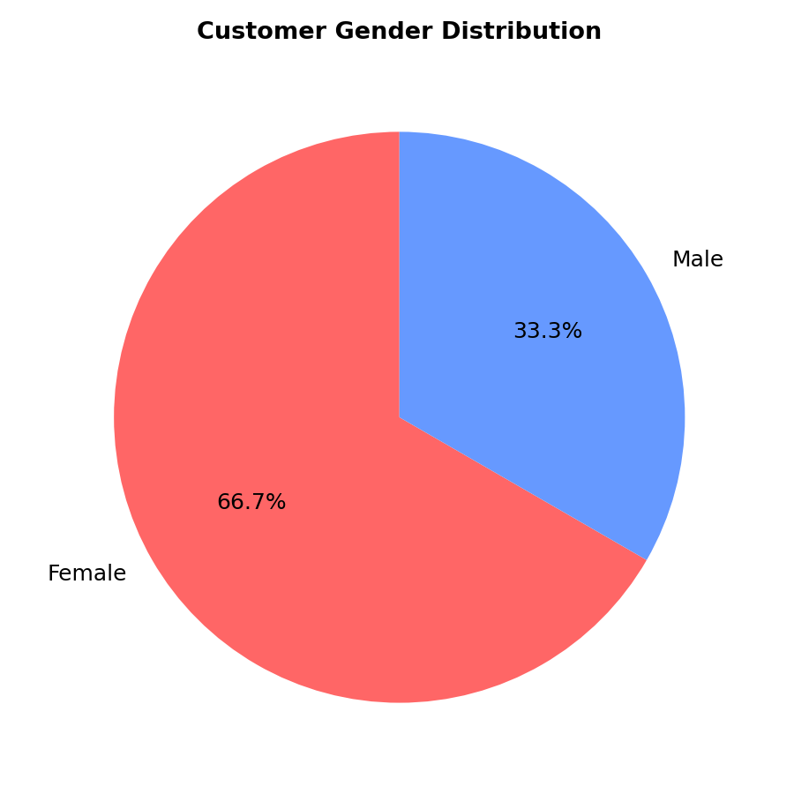
c) Build a table to show the demographic information for each customer. Label the table elements.
R code:
# Display the table
print(customer)

# Formatted table
install.packages("gridExtra")
library(gridExtra)
grid.table(customer)
output:
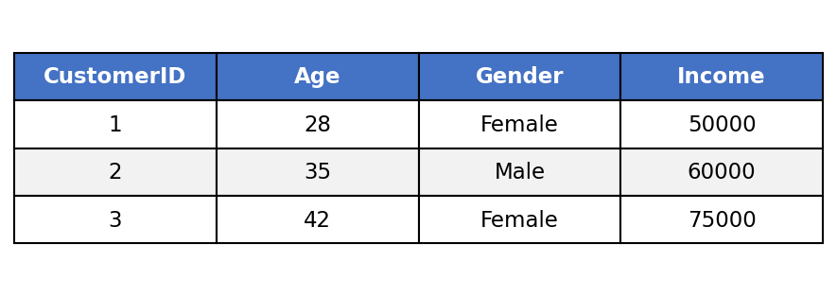
d) Develop a Tableau dashboard combining the bar chart, pie chart, and the table for interactive exploration of customer demographics.
R code (dashboard simulation):
par(mfrow = c(1, 2))
barplot(customer$Age,
names.arg = customer$CustomerID,
col = "skyblue",
xlab = "Customer ID", ylab = "Age",
main = "Customer Ages")
pie(gender_count,
labels = names(gender_count),
col = c("pink", "lightblue"),
main = "Gender Distribution")
output:
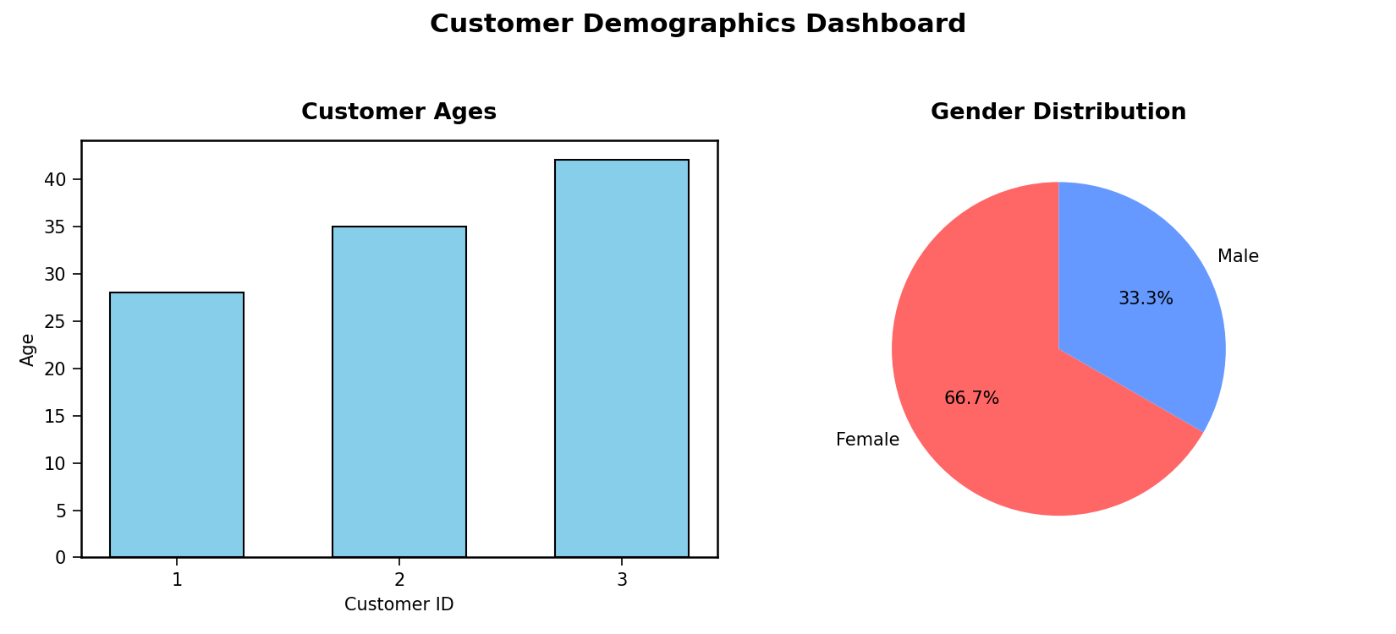

Set 17: Employee Performance Analysis
a) Create a line chart to visualize the performance trend of employees over time. Label the axes and title the chart.
R code:
# Dataset
employee <- data.frame(
EmployeeID = c(1, 2, 3),
Department = c("Sales", "HR", "Marketing"),
YearsService = c(5, 3, 7),
Performance = c(85, 92, 78)
)

# Line Chart
employee <- employee[order(employee$YearsService), ]
plot(employee$YearsService,
employee$Performance,
type = "o",
col = "blue",
pch = 16,
lwd = 2,
xlab = "Years of Service",
ylab = "Performance Score",
main = "Employee Performance Trend")
legend("topright", legend = "Performance", col = "blue", lty = 1, pch = 16)
output:
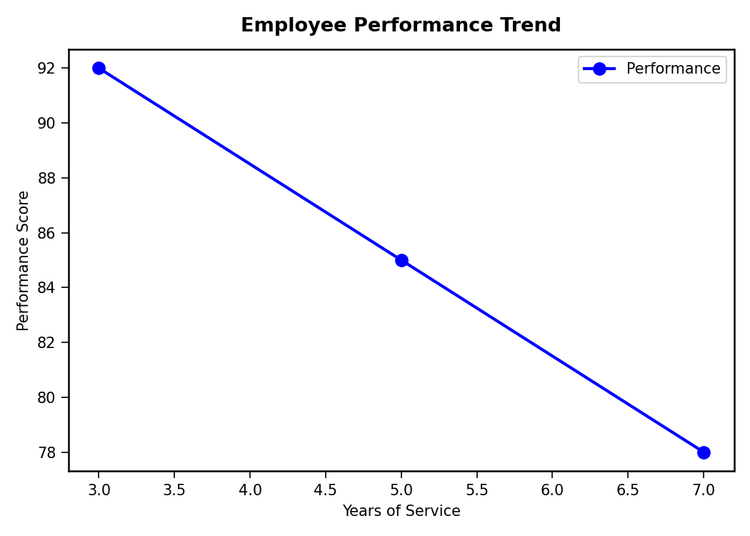
b) Generate a bar chart showing the distribution of employees across different departments. Label the chart elements.
R code:
# Department count
dept_count <- table(employee$Department)

# Bar Chart
barplot(dept_count,
col = c("skyblue", "orange", "green"),
xlab = "Department",
ylab = "Number of Employees",
main = "Employees by Department")
output:
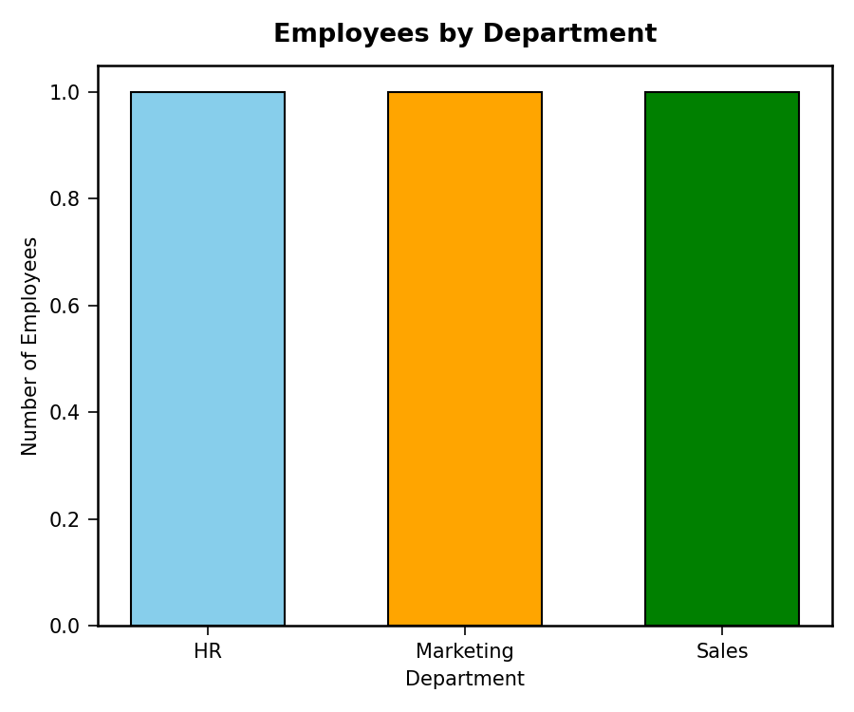
c) Build a table to display the performance data for each employee. Label the table elements.
R code:
print(employee)
install.packages("gridExtra")
library(gridExtra)
grid.table(employee)
output:
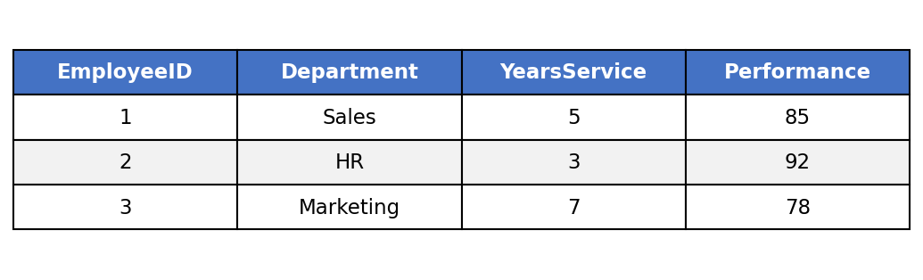
d) Develop a Tableau dashboard combining the line chart, bar chart, and the table for interactive exploration of employee performance data.
R code (dashboard simulation):
par(mfrow = c(1, 2))
plot(employee$YearsService,
employee$Performance,
type = "o", col = "blue", pch = 16, lwd = 2,
xlab = "Years of Service", ylab = "Performance Score",
main = "Performance Trend")
barplot(dept_count,
col = c("skyblue", "orange", "green"),
xlab = "Department", ylab = "Number of Employees",
main = "Employees by Department")
output:
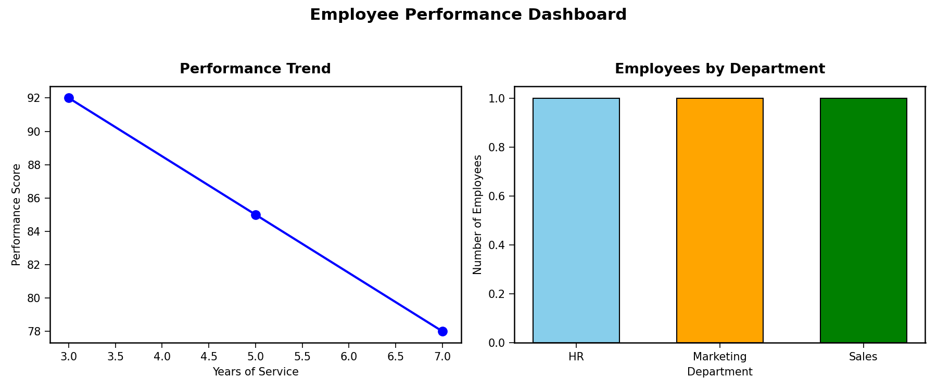

Set 18: Product Inventory Management
a) Create a bar chart to visualize the quantity of each product in the inventory. Label the axes and title the chart.
R code:
# Dataset
inventory <- data.frame(
ProductID = c(1, 2, 3),
ProductName = c("Product A", "Product B", "Product C"),
Quantity = c(250, 175, 300),
Price = c(20, 15, 18)
)

# Bar Chart
barplot(inventory$Quantity,
names.arg = inventory$ProductName,
col = "skyblue",
xlab = "Product Name",
ylab = "Quantity Available",
main = "Product Inventory")
output:
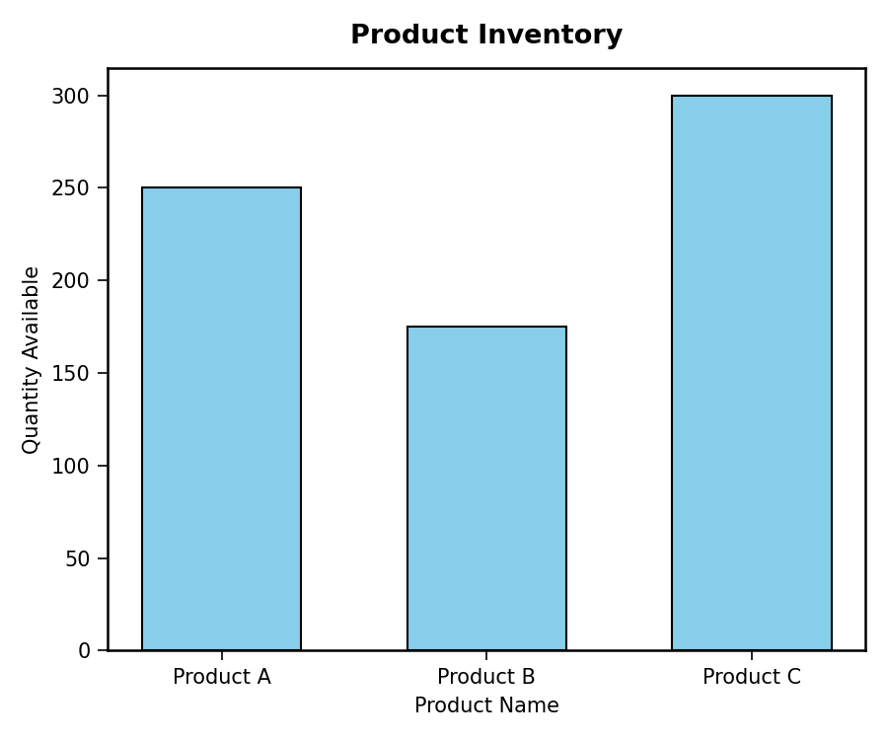
b) Generate a stacked bar chart to show the quantity of each product within different product categories.
R code:
# Add Category
inventory$Category <- c("Electronics", "Electronics", "Furniture")

# Frequency Table
table_data <- xtabs(Quantity ~ Category + ProductName, data = inventory)

# Stacked Bar Chart
barplot(table_data,
beside = FALSE,
col = rainbow(ncol(table_data)),
main = "Product Quantity by Category",
xlab = "Category",
ylab = "Quantity")
legend("topright", legend = colnames(table_data), fill = rainbow(ncol(table_data)), title = "Products")
output:
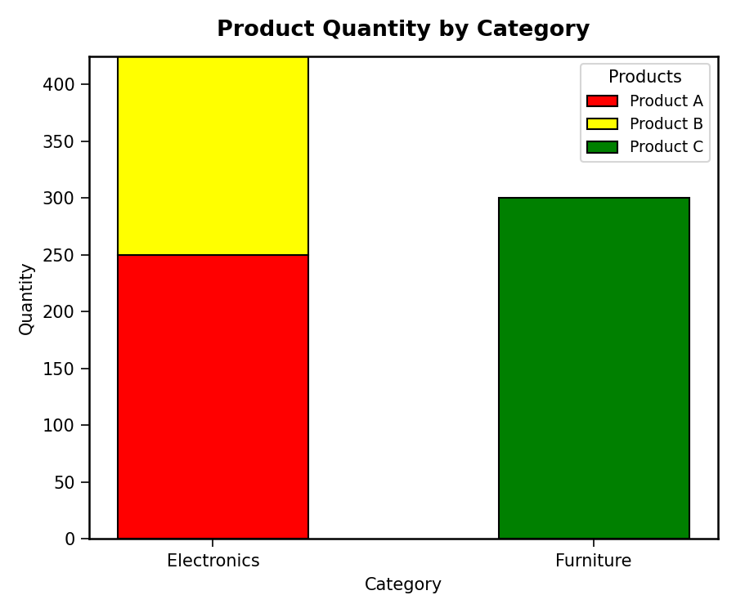
c) Build a table to show the inventory data for each product. Label the table elements.
R code:
print(inventory)
install.packages("gridExtra")
library(gridExtra)
grid.table(inventory)
output:
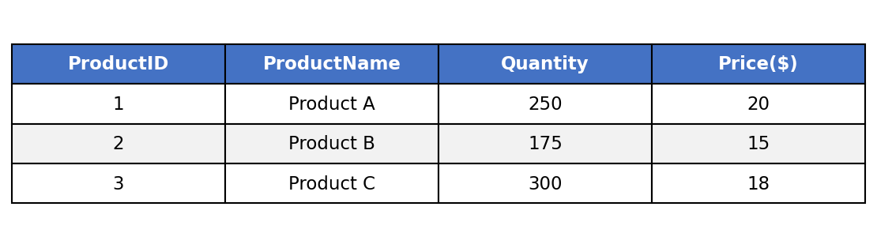
d) Develop a Tableau dashboard combining the bar chart, stacked bar chart, and the table for interactive exploration of inventory data.
R code (dashboard simulation):
par(mfrow = c(1, 2))
barplot(inventory$Quantity,
names.arg = inventory$ProductName,
col = "skyblue", xlab = "Product Name", ylab = "Quantity",
main = "Product Inventory")
barplot(table_data,
beside = FALSE, col = rainbow(ncol(table_data)),
xlab = "Category", ylab = "Quantity",
main = "Quantity by Category")
legend("topright", legend = colnames(table_data), fill = rainbow(ncol(table_data)))
output:
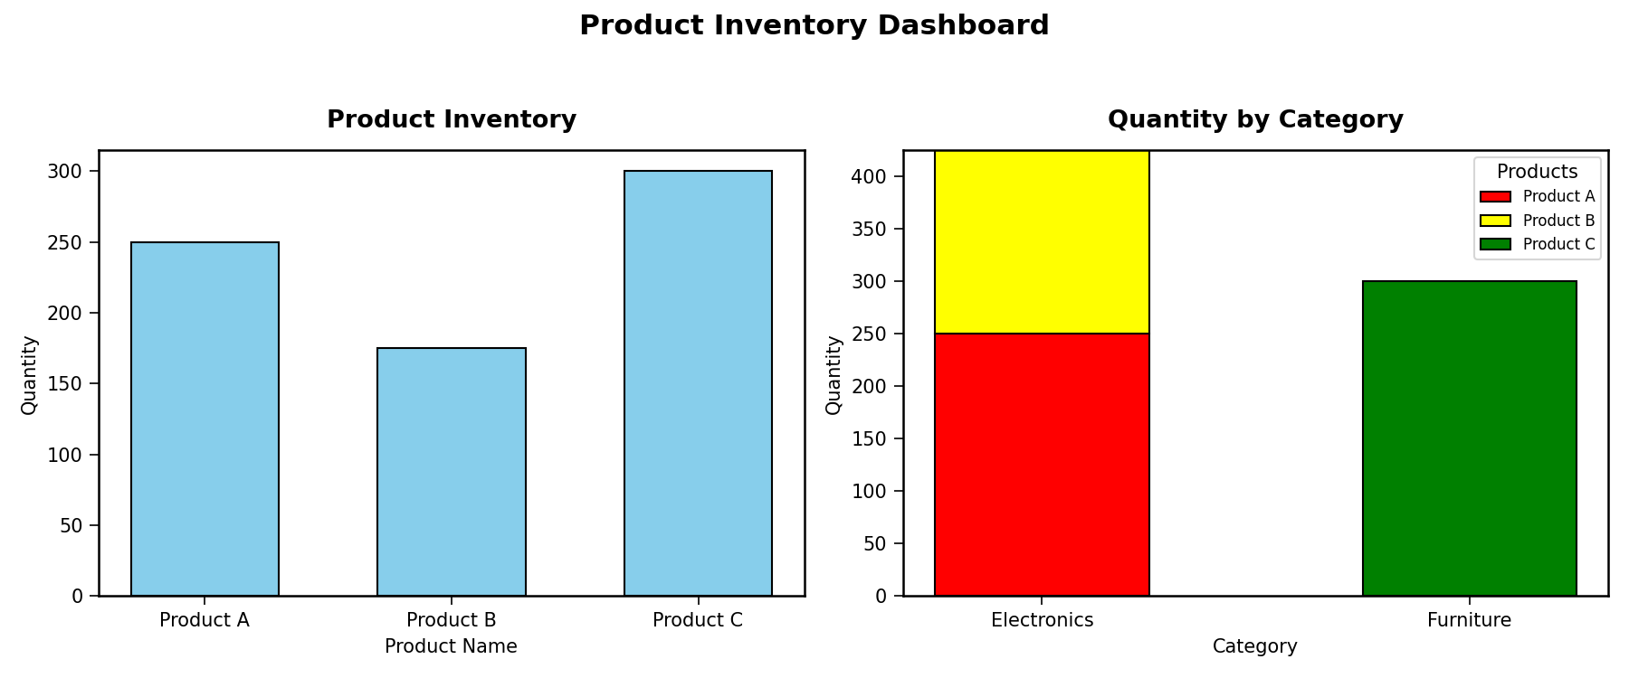

Set 19: Survey Responses Analysis
a) Create a grouped bar chart to visualize the distribution of answers for Question 1. Label the chart elements.
R code:
# Dataset
survey <- data.frame(
SurveyID = c(1, 2, 3),
Question1 = c("A", "B", "C"),
Question2 = c("B", "A", "A"),
Question3 = c("C", "D", "B")
)

# Frequency of Question 1 answers
q1_count <- table(survey$Question1)

# Bar Chart
barplot(q1_count,
col = "orange",
xlab = "Answer Option",
ylab = "Frequency",
main = "Distribution of Answers - Question 1")
output:
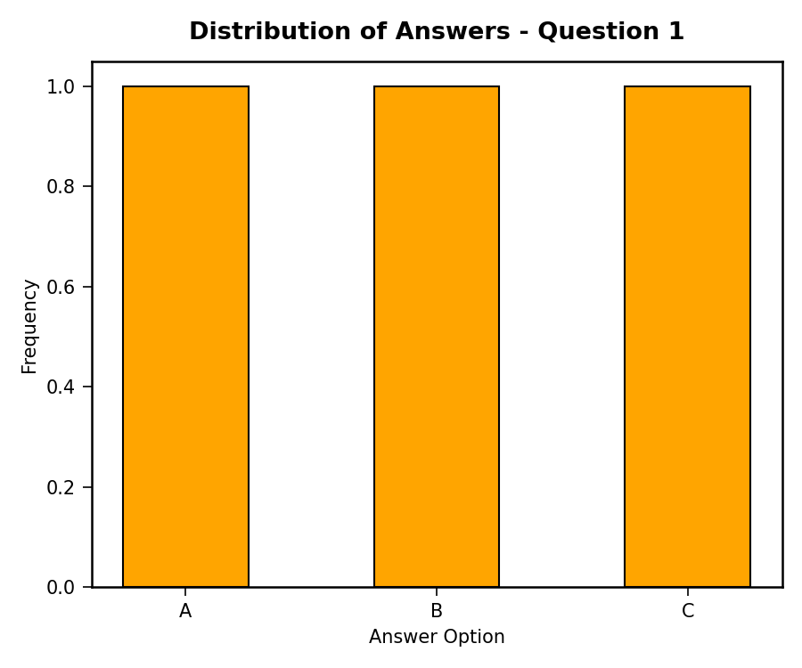
b) Generate a stacked bar chart to represent the overall distribution of responses for all three questions.
R code:
# Combine counts for all questions
q_counts <- rbind(
table(factor(survey$Question1, levels = c("A","B","C","D"))),
table(factor(survey$Question2, levels = c("A","B","C","D"))),
table(factor(survey$Question3, levels = c("A","B","C","D")))
)
rownames(q_counts) <- c("Question 1", "Question 2", "Question 3")

# Stacked Bar Chart
barplot(t(q_counts),
beside = FALSE,
col = rainbow(4),
xlab = "Question",
ylab = "Number of Responses",
main = "Overall Distribution of Survey Responses")
legend("topright", legend = colnames(q_counts), fill = rainbow(4), title = "Answer")
output:
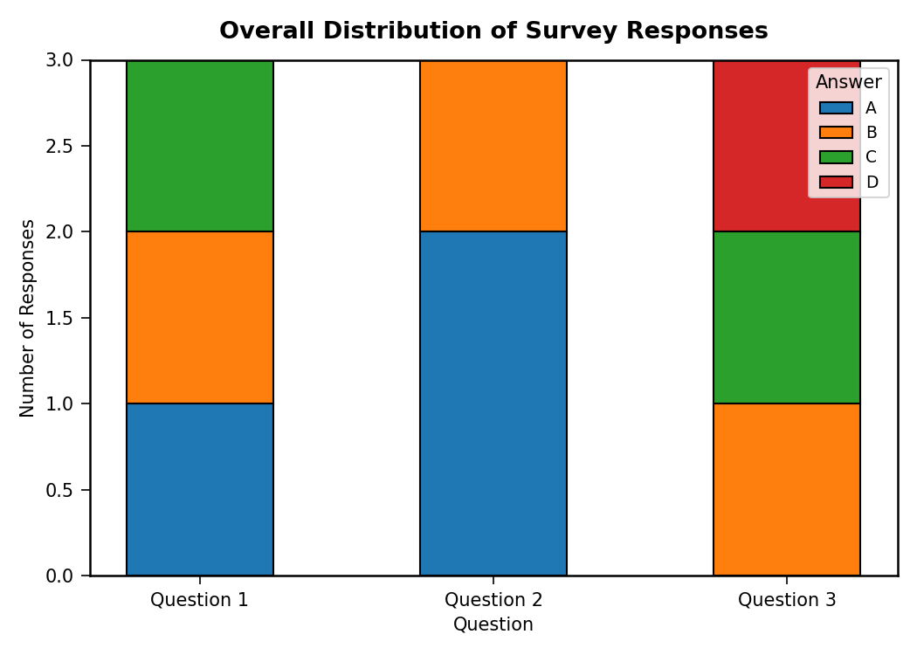
c) Build a table to show the survey response data for each survey. Label the table elements.
R code:
print(survey)
install.packages("gridExtra")
library(gridExtra)
grid.table(survey)
output:
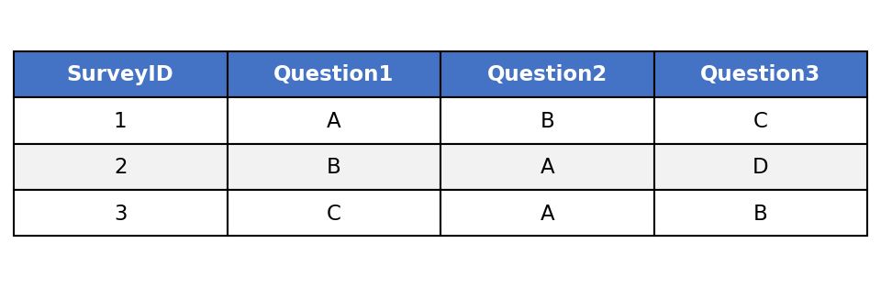
d) Develop a Tableau dashboard combining the grouped bar chart, stacked bar chart, and the table for interactive exploration of survey responses.
R code (dashboard simulation):
par(mfrow = c(1, 2))
barplot(q1_count,
col = "orange", xlab = "Answer Option", ylab = "Frequency",
main = "Question 1 Responses")
barplot(t(q_counts),
beside = FALSE, col = rainbow(4),
xlab = "Question", ylab = "Responses",
main = "All Questions Distribution")
legend("topright", legend = colnames(q_counts), fill = rainbow(4))
output:
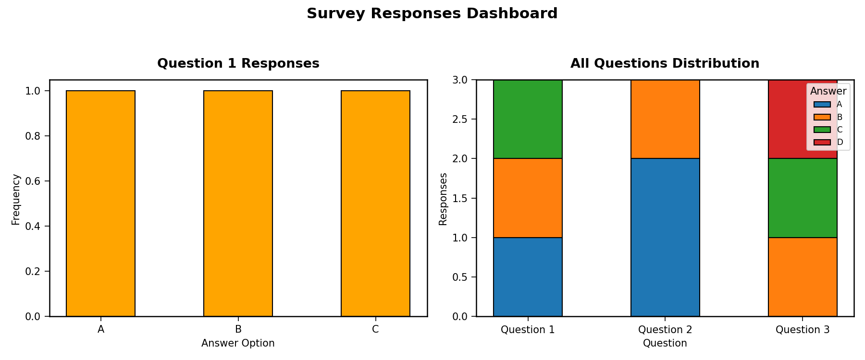

Set 20: Stock Analysis
a) Create a line chart to visualize the stock prices of three companies (Stock A, Stock B, and Stock C) over a specific time period. Label the axes and title the chart.
R code:
# Dataset
stocks <- data.frame(
Date = as.Date(c("2023-01-01", "2023-01-02", "2023-01-03")),
StockA = c(100, 105, 110),
StockB = c(150, 152, 148),
StockC = c(120, 118, 122)
)

# Line Chart
plot(stocks$Date, stocks$StockA,
type = "o", col = "blue", lwd = 2,
ylim = range(c(stocks$StockA, stocks$StockB, stocks$StockC)),
xlab = "Date", ylab = "Stock Price ($)",
main = "Stock Prices Over Time")
lines(stocks$Date, stocks$StockB, type = "o", col = "red", lwd = 2)
lines(stocks$Date, stocks$StockC, type = "o", col = "green", lwd = 2)
legend("topleft", legend = c("Stock A","Stock B","Stock C"),
col = c("blue","red","green"), lty = 1, pch = 1)
output:
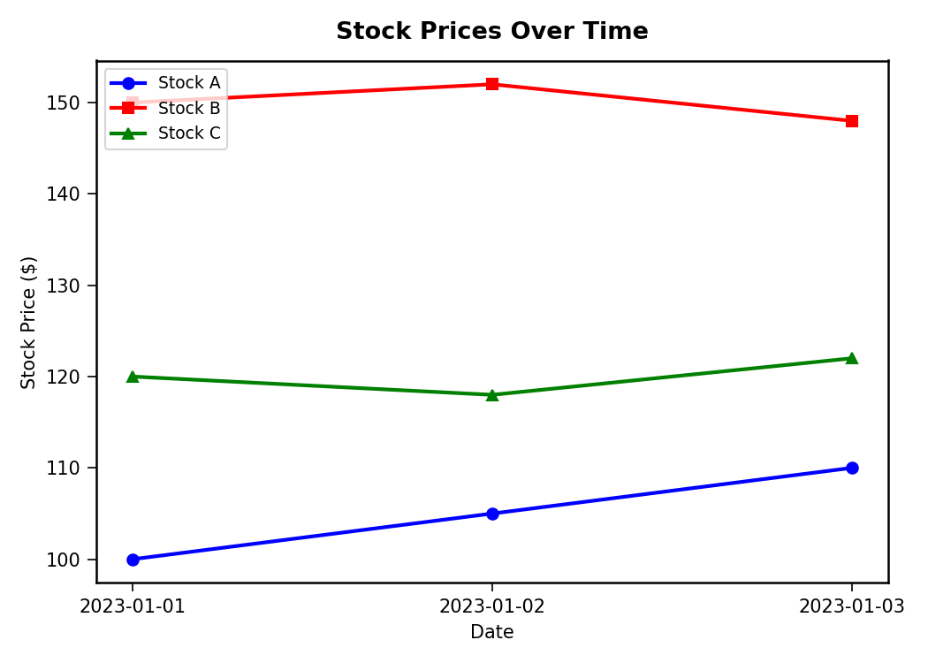
b) Generate a bar chart showing the daily percentage change in stock prices for Stock A. Label the chart elements.
R code:
# Daily % change for Stock A
pct_change <- c(NA, round(diff(stocks$StockA) / head(stocks$StockA, -1) * 100, 2))

# Bar Chart
barplot(pct_change[-1],
names.arg = as.character(stocks$Date[-1]),
col = "purple",
xlab = "Date",
ylab = "% Change",
main = "Daily % Change - Stock A")
output:
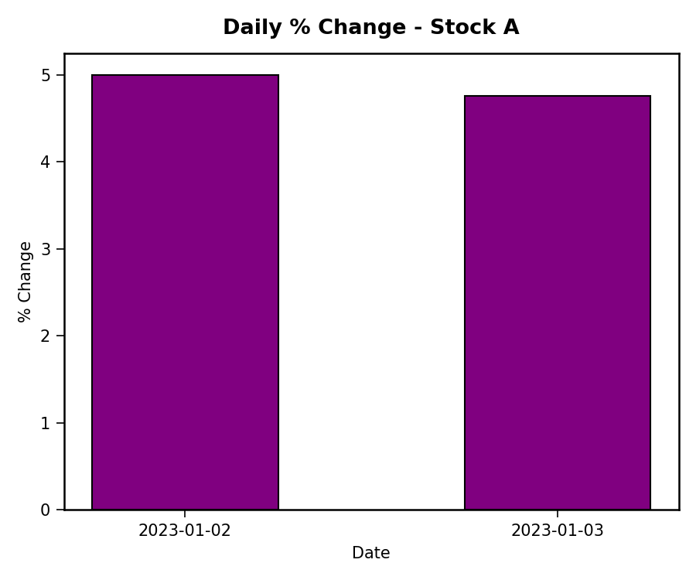
c) Build a table to display the stock price data for each company over the given period. Label the table elements.
R code:
print(stocks)
install.packages("gridExtra")
library(gridExtra)
grid.table(stocks)
output:
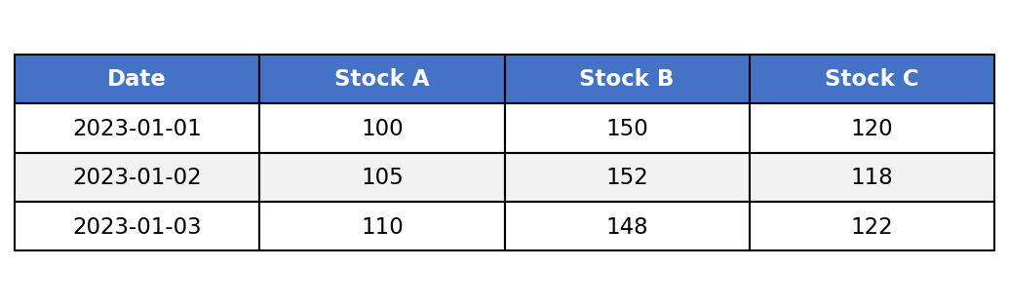
d) Develop a Tableau dashboard combining the line chart, bar chart, and the table for interactive exploration of stock prices.
R code (dashboard simulation):
par(mfrow = c(1, 2))
plot(stocks$Date, stocks$StockA,
type = "o", col = "blue", lwd = 2,
ylim = range(c(stocks$StockA, stocks$StockB, stocks$StockC)),
xlab = "Date", ylab = "Price ($)", main = "Stock Prices")
lines(stocks$Date, stocks$StockB, type = "o", col = "red", lwd = 2)
lines(stocks$Date, stocks$StockC, type = "o", col = "green", lwd = 2)
barplot(pct_change[-1],
names.arg = as.character(stocks$Date[-1]),
col = "purple", xlab = "Date", ylab = "% Change",
main = "Stock A % Change")
output:
